The Socratic Agent: Reflexion
Applied AI, Volume III — Part 15
There's a difference between how Ankur and Priya prepare for UPSC.
Ankur re-reads his notes. Covers the same chapters, the same highlighted sections, the same summary pages. He reads until the exam.
Priya tests herself. After each chapter she closes the book, writes down everything she remembers, then opens the book to check what she missed. She makes notes not on what she read — but on what she got wrong.
Ankur walks into the exam confident. Priya walks in having already failed twenty mock questions and fixed each mistake.
Reflexion is Priya's method, implemented in code.

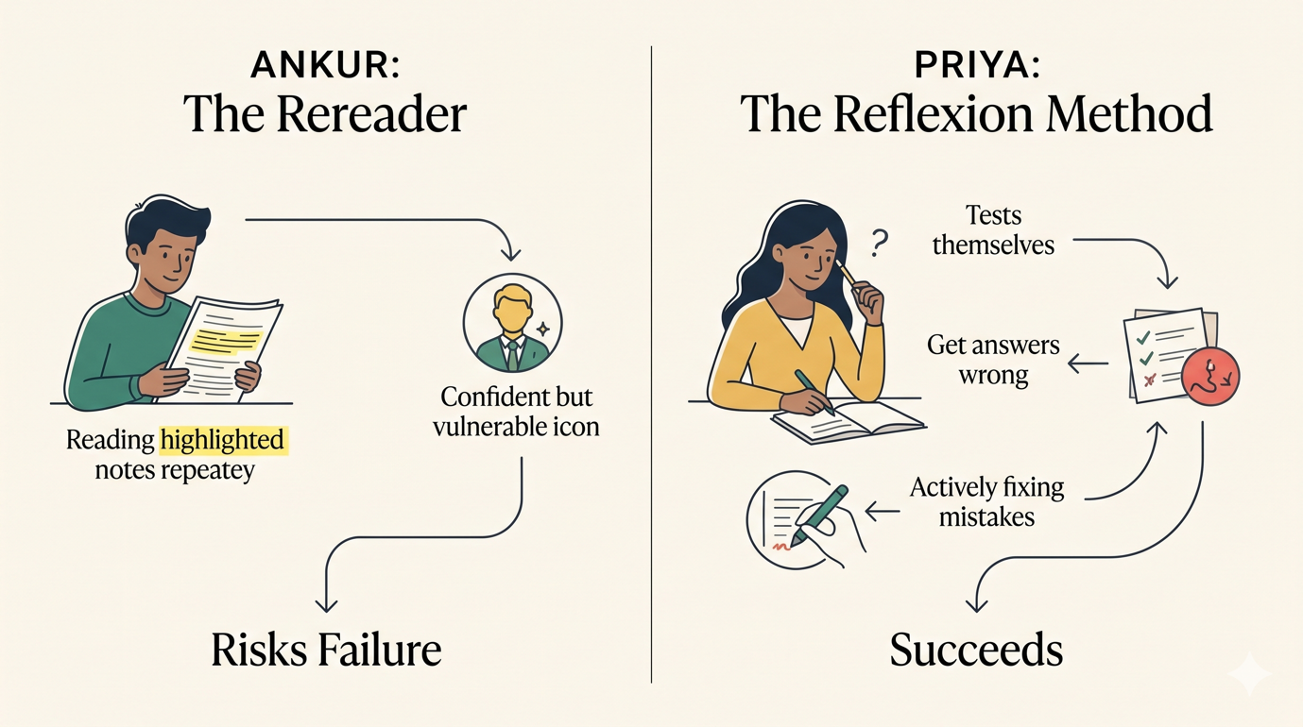

Diagram 1: The Core Analogy (Ankur vs. Priya)

Why Agents Get the First Answer Wrong
A ReActAgent reasons step-by-step, uses tools, and produces a final answer. This works well for factual lookups and clear procedural tasks.
But some tasks have evaluation dimensions the agent doesn't naturally check. A complaint resolution agent might:
- Check the return window (expired). Refuse the refund. Done.
- Never check the warranty policy (which has a 6-month window for defective products).
The answer it gives is internally consistent. Return window is expired — refused. But it's wrong, because there's a second applicable policy the agent didn't think to check.
You can add this to the system prompt. You can add examples. You can add explicit tool descriptions that hint at when each tool applies. And you should do all of those things.
But Reflexion is the safety net after all of that. It says: even after you've done everything right in the prompt, let the agent check its own work.

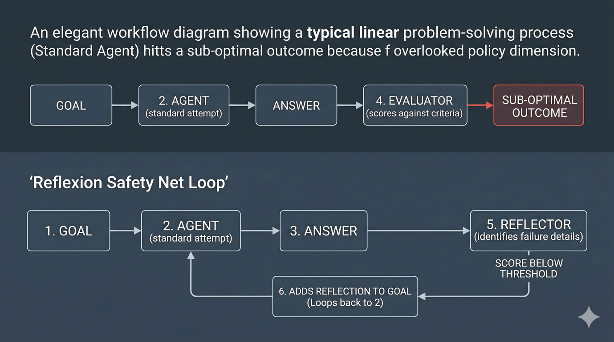

Diagram 2: Why Agents Fail & The Reflexion Safety Net

The Reflexion Loop
The diagram provided in the text can be expanded into three core, specialized components.
Three components:
The base agent. A standard ReActAgent. It doesn't know it's being evaluated. It just runs.
The evaluator. An LLM call (same model, separate conversation) that scores the answer 1–5 against explicit criteria. Not vague — explicit:
1. Did the agent check ALL applicable policies?
2. Is the resolution consistent with the policy?
3. Was the customer's premium status considered?
4. Was the resolution logged via process_resolution?
5. Is the explanation clear enough for the customer?
The reflector. When the score is too low, another LLM call generates a reflection: what specifically went wrong and what to try differently.

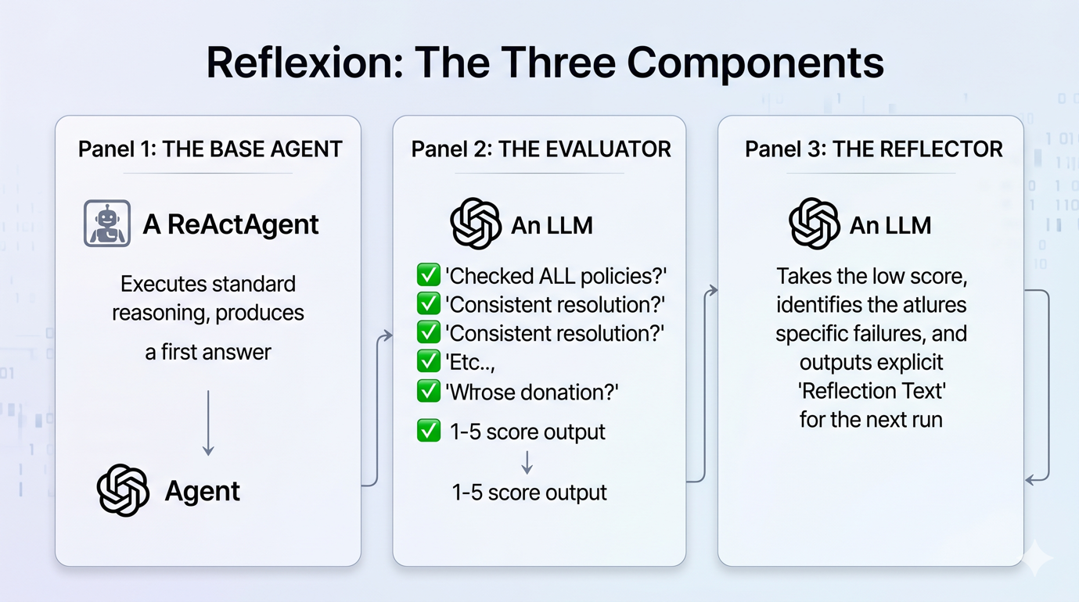

Diagram 3: Components of Reflexion

The Code
Python
from vol3_agents.part13_react_patterns.react_loop import ReActAgent, Tool
from vol3_agents.part15_reflexion.reflexion import ReflexionAgent

base_agent = ReActAgent(tools=TOOLS, max_steps=10, max_tokens_total=30_000)

agent = ReflexionAgent(
base_agent=base_agent,
evaluation_criteria="""
1. Did the agent check ALL applicable policies (return AND warranty)?
2. Is the resolution correct based on policy?
3. Was the resolution logged via process_resolution?
""",
max_attempts=3,
min_score=4.0,
)

result = agent.run("Resolve complaint for BA-55421. Customer says earbuds stopped working after 38 days.")
print(result.final_answer)
print(f"Attempts: {len(result.attempts)} | Succeeded: {result.succeeded}")

A Real Example
The complaint: Ananya bought Boult Audio earbuds (₹1,299). They stopped working after 38 days. Standard return window is 30 days. But there's a 6-month warranty on defective products.
Here is how Reflexion navigates this scenario.

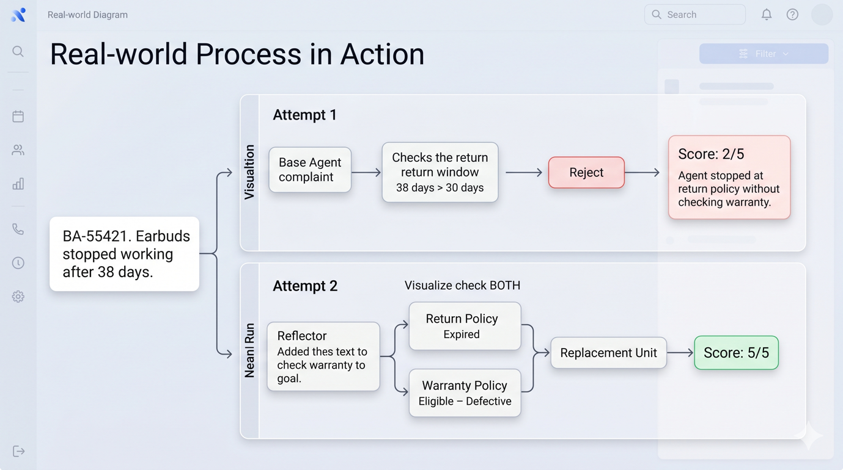

Diagram 4: A Real Example in Action (Attempt 1 vs. Attempt 2)

When to Use Reflexion (and When Not To)
Reflexion is powerful, but it's not free. It earns its keep on high-stakes decisions, not on simple factual lookups.

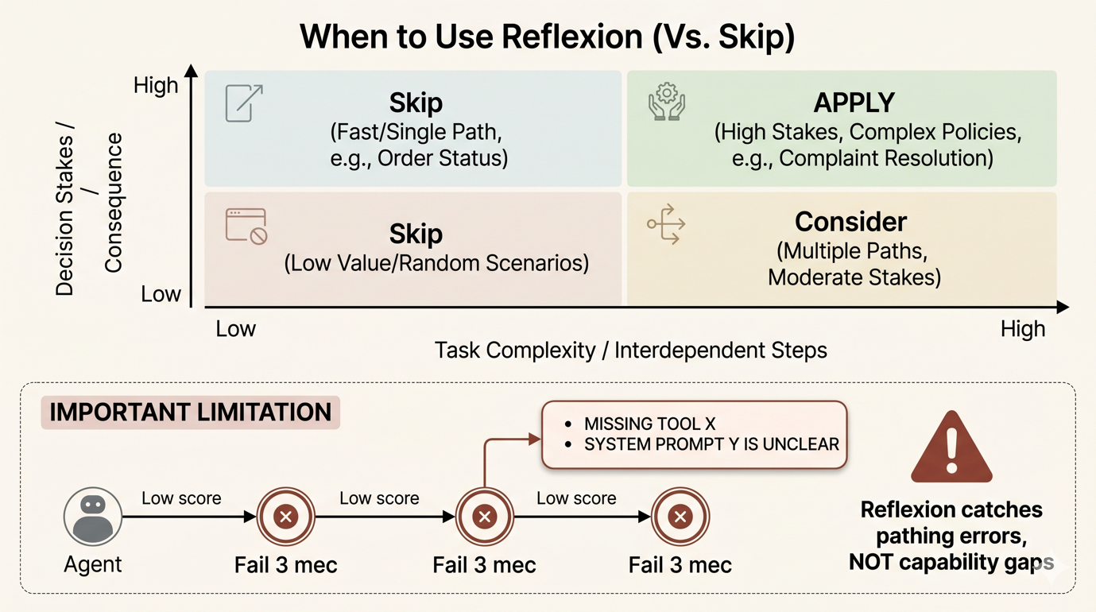

Diagram 5: When to Use Reflexion & Crucial Limitations

One Honest Thing
Reflexion doesn't fix a bad agent. If the base agent is consistently missing something across all attempts, the reflection will say so consistently — but the fix is to add the tool or update the system prompt, not to add more retry cycles.
Think of it this way: Reflexion catches the case where the agent could have gotten it right with the tools available, but took the wrong path. It can't fix the case where the right path doesn't exist.
Priya passed her prelims. Ankur is still highlighting.

